SUBJECT: OBJECT ORIENTED PROGRAMMING

Submitted To: Engr. Asmatullah

Submitted By: Asadullah Samo (21SW036)

Dated: 05-06-2022

Lab: Lab-04 Tasks

**Question 01:**

Write a java program that takes a single character as input and tells whether it is a vowel or a consonant. (Use Switch Statement)

Source Code:

**package** Lab_04_Tasks;

**import** java.util.Scanner;

**public** **class** Lab_04_Task_01 {

**public** **static** **void** main(String[] args) {

// Task 01: Checking Vowel OR Consonant using Switch Statement

Scanner sc = **new** Scanner(System.in);

System.out.print("Enter any alphabet: ");

**char** alphabet = sc.next().charAt(0);

**switch**(alphabet)

{

**case** 'a':

System.out.println(alphabet+" is Vowel");

**break**;

**case** 'e':

System.out.println(alphabet+" is Vowel");

**break**;

**case** 'i':

System.out.println(alphabet+" is Vowel");

**break**;

**case** 'o':

System.out.println(alphabet+" is Vowel");

**break**;

**case** 'u':

System.out.println(alphabet+" is Vowel");

**break**;

**case** 'A':

System.out.println(alphabet+" is Vowel");

**break**;

**case** 'E':

System.out.println(alphabet+" is Vowel");

**break**;

**case** 'I':

System.out.println(alphabet+" is Vowel");

**break**;

**case** 'O':

System.out.println(alphabet+" is Vowel");

**break**;

**case** 'U':

System.out.println(alphabet+" is Vowel");

**break**;

**default**:

System.out.println(alphabet+" is Consonant");

} // end of switch statement

} // end of main() method

} // end of program

OUTPUT:

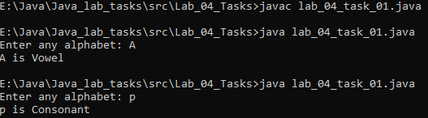

**Question 02:**

Write a java program that performs arithmetic operations on two numbers after taking 3 runtime arguments; 1st number, 2nd number and the operators (+, -, /, *) and prints the result.

Source Code:

**package** Lab_04_Tasks;

**import** java.util.Scanner;

**public** **class** Lab_04_Task_02 {

**public** **static** **void** main(String[] args) {

// Task 02: Calculator

Scanner sc = **new** Scanner(System.***in***);

System.***out***.print("Enter first number, operator, second number: ");

**int** num1 = sc.nextInt();

**char** op = sc.next().charAt(0);

**int** num2 = sc.nextInt();

**int** result = 0;

**switch**(op){

**case** '+':

result = num1 + num2;

**break**;

**case** '-':

result = num1 - num2;

**break**;

**case** '*':

result = num1 * num2;

**break**;

**case** '/':

result = num1 / num2;

**break**;

**case** '%':

result = num1 % num2;

**break**;

} // end of switch statement

System.***out***.println(num1+" "+op+" "+num2+" = "+result);

} // end of main() method

} // end of program

OUTPUT:

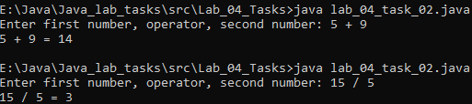

**Question 03:**

Write a java program which check whether a number is prime or not.

Source Code:

**package** Lab_04_Tasks;

**import** java.util.Scanner;

**public** **class** Lab_04_Task_03{

**public** **static** **void** main(String[] args) {

// Task 03: Checking whether a number is prime or not

Scanner sc = **new** Scanner(System.***in***);

System.***out***.println("Enter a positive number: ");

**int** num = sc.nextInt();

**int** i;

**boolean** isPrime = **true**;

**if**(num==0 || num==1)

isPrime = **false**;

**for**(i=2; i<=num/2; i++) // loop till i=2 to i<=num/2 (because we know there is no factor beyond num/2. So, any iteration beyond num/2 is redundant )

{

**if**(num%i==0)

{

isPrime = **false**;

**break**;

} // end of if statement

} // end of for loop

**if**(isPrime){ // same as isPrime==true

System.***out***.println(num+" is a prime number");

} **else** {

System.***out***.println(num+" is not a prime number");

} // end of if else

} // end of main() method

} // end of program

OUTPUT:

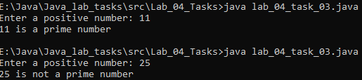

**Question 04:**

Write a java program that takes five subjects marks of a student and calculate their percentage and grade.

Source Code:

**package** Lab_04_Tasks;

**import** java.util.Scanner;

**public** **class** Lab_04_Task_04 {

**public** **static** **void** main(String[] args) {

// Question 04: Finding percentage and Grade of student using marks of five subjects

Scanner sc = **new** Scanner(System.***in***);

System.***out***.print("Enter marks for OOP: ");

**int** OOP = sc.nextInt();

System.***out***.print("Enter marks for DSA: ");

**int** DSA = sc.nextInt();

System.***out***.print("Enter marks for PP: ");

**int** PP = sc.nextInt();

System.***out***.print("Enter marks for ISE: ");

**int** ISE = sc.nextInt();

System.***out***.print("Enter marks for IS: ");

**int** IS = sc.nextInt();

**int** sum = OOP+PP+DSA+ISE+IS;

**float** percentage = (**float**) (sum*100)/500;

System.***out***.println("Percentage is: "+percentage);

**if**(percentage>=50 && percentage<60){

System.***out***.println("Your grade is C");

} **else** **if**(percentage>=60 && percentage<67){

System.***out***.println("Your grade is C+");

} **else** **if**(percentage>=67 && percentage<75){

System.***out***.println("Your grade is B");

} **else** **if**(percentage>=75 && percentage<83){

System.***out***.println("Your grade is B+");

} **else** **if**(percentage>=83 && percentage<90){

System.***out***.println("Your grade is A");

} **else** **if**(percentage>=90){

System.***out***.println("Your grade is A+");

} **else** {

System.***out***.println("You are fail");

} // end of if else

} // end of main() method

} // end of program

OUTPUT:

